C.A.L.P Newsletter
The Chattanooga Association of Landscape Professionals
www.chattanoogalandscapers.com
P.O. Box 25674, Chattanooga, Tennessee 37422

May, 2013

Join Us for This Month’s Program!

WHAT: A talk and tour of the beautiful property of Jane and George Diamantis

WHEN: Tuesday May 28, 2013 6:30 p.m.

WHERE: 6508 White Oak Valley Circle, McDonald, TN 37353.

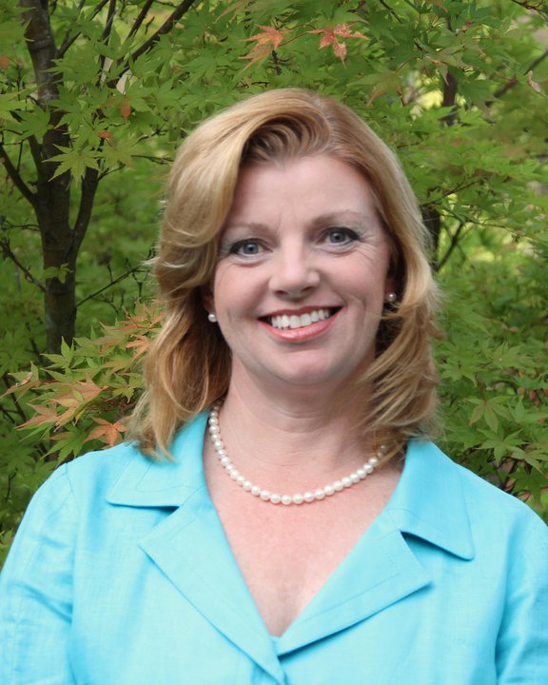

Please join us for a talk and tour of the beautiful property of Jane and George Diamantis. Jane Diamantis is a 1986 graduate of the Georgia Master Gardener program. After working in the florist and nursery trades, she opened Diamantis Landscape Design in 1996. Currently, she serves on the board of the American Horticultural Society as First Vice-Chairman.

ANNOUNCEMENTS



LOCAL BUSINESS OWNERS: If your business has changed in any way please contact a
board member!

C.A.L.P MEETINGS: C.A.L.P has monthly board meetings on the 2nd Tuesday of each month @ 8 A.M @ the UT Extension office off of Bonny Oak Dr. To attend membership is encouraged. Our monthly meetings with special guest speakers are on the 4th Tuesday of each month. To get the latest information about our speakers and meetings please visit our website at chattanoogalandscapers.com or look out for our monthly newsletters. Please contact a board member for any questions.

C.A.L.P. MEMBERS: Below is the list of officers nominated to serve the CALP for the years 2013 & 2014. The members who attend the April 23rd meeting will be asked to vote on acceptance of the list of officers.

Upcoming events

Two CALP Board Members will be presenting this year at UTK's Bloom Days Event on May 11-12. (www.utgardens.tennessee.edu/bloomsdays)
Scott Drucker, VP of Speakers will be presenting on Saturday, May 11, 2013 at 11:30AM on "Heirloom Gardening". Tom Stebbins, Hamilton County Agricultural Extension Agent and CALP Advisor will be presenting on "Yard Pest Detectives" on Sunday, May 12PM at 1:30 PM.

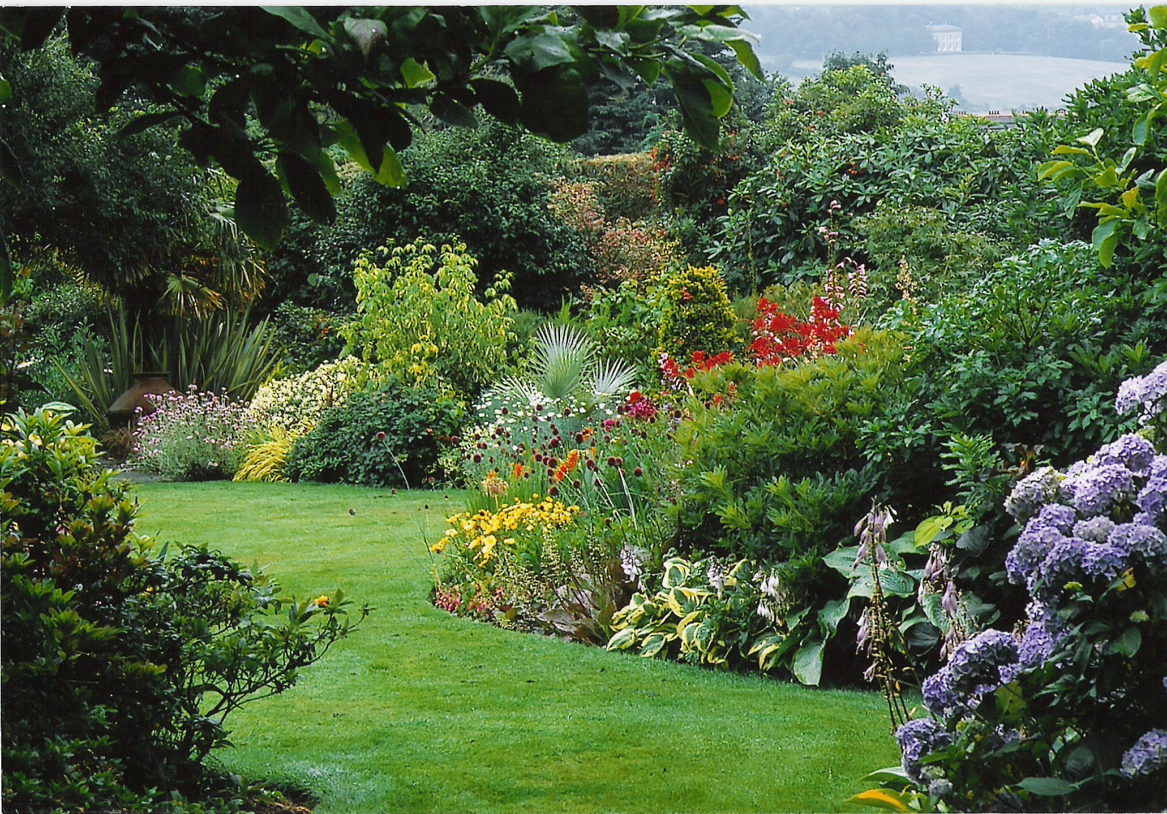

President - Sam Manning - The Grass is Greener (423) 704-2362
1st VP of Programs - Scott Drucker - Dream Gardens Landscape Design (423) 822-6052
2nd VP of Newsletter - Sasha Eidson - Carroll Landscaping (423)227-0360
3rd VP of Membership – Paul Paschall
Secretary - John Beaty
Treasurer - Ray Tessmer
Advisor - Tom Stebbins-UT Extension (423)855-6115

